**Output of all APIs**

1. GET/metrics

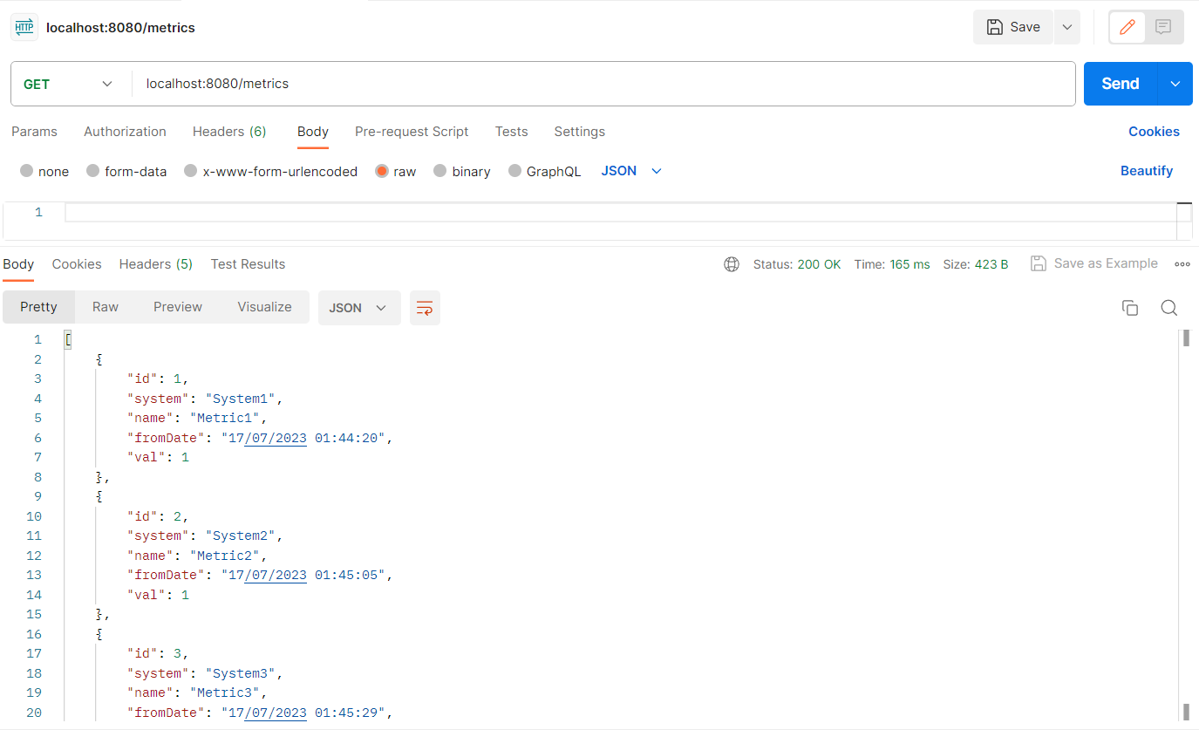

1. GET/metrics/{id}

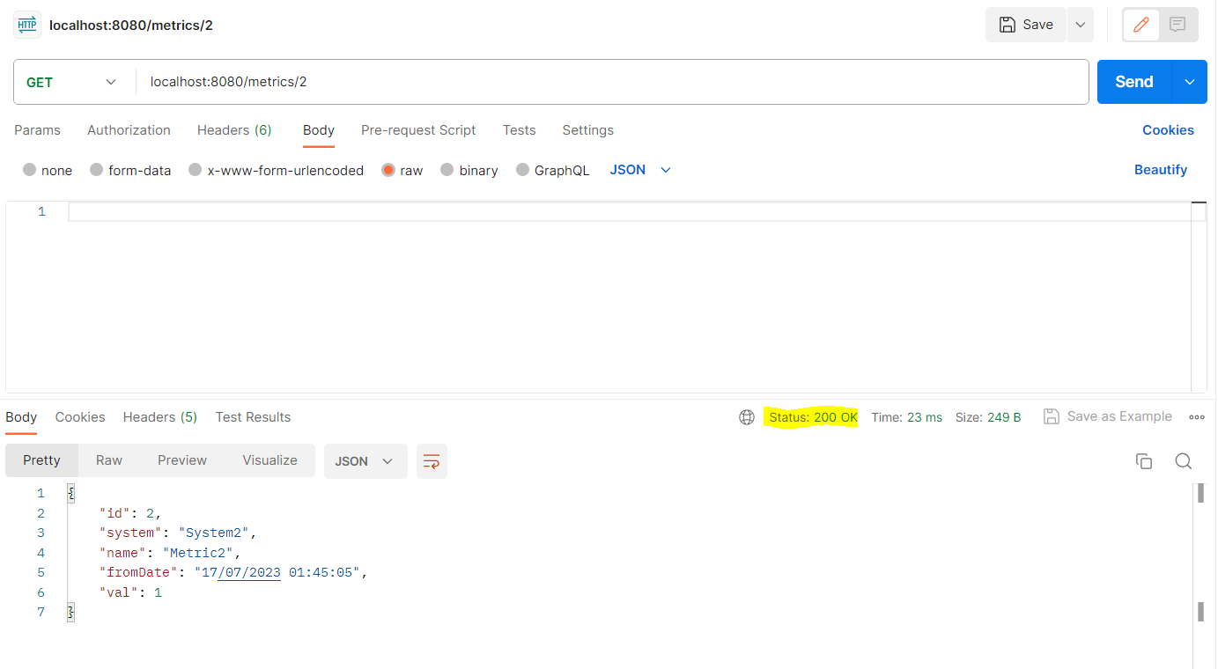

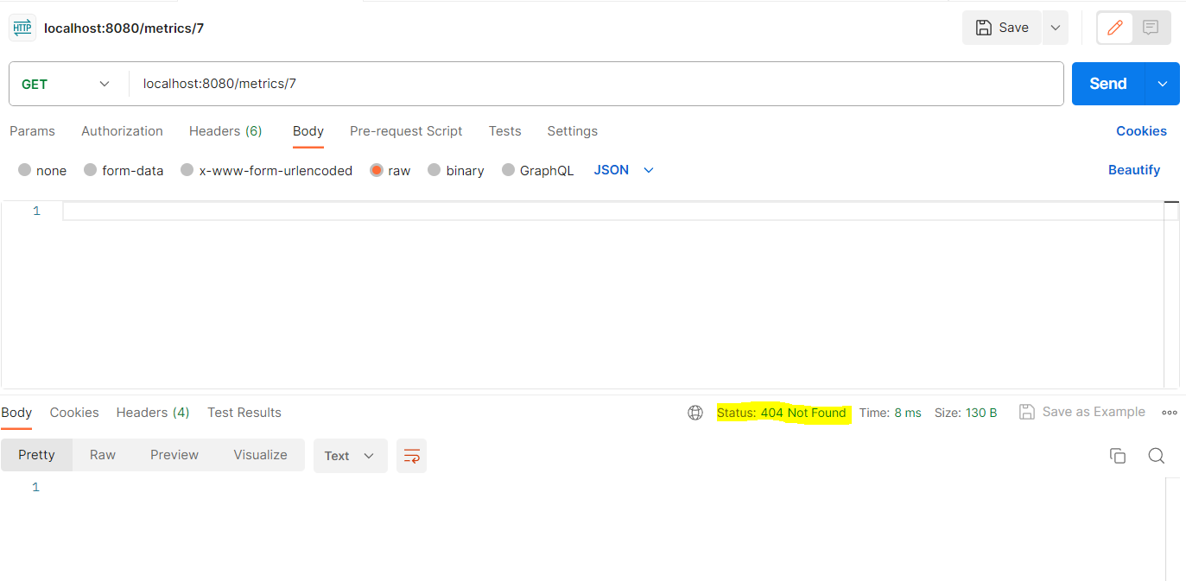

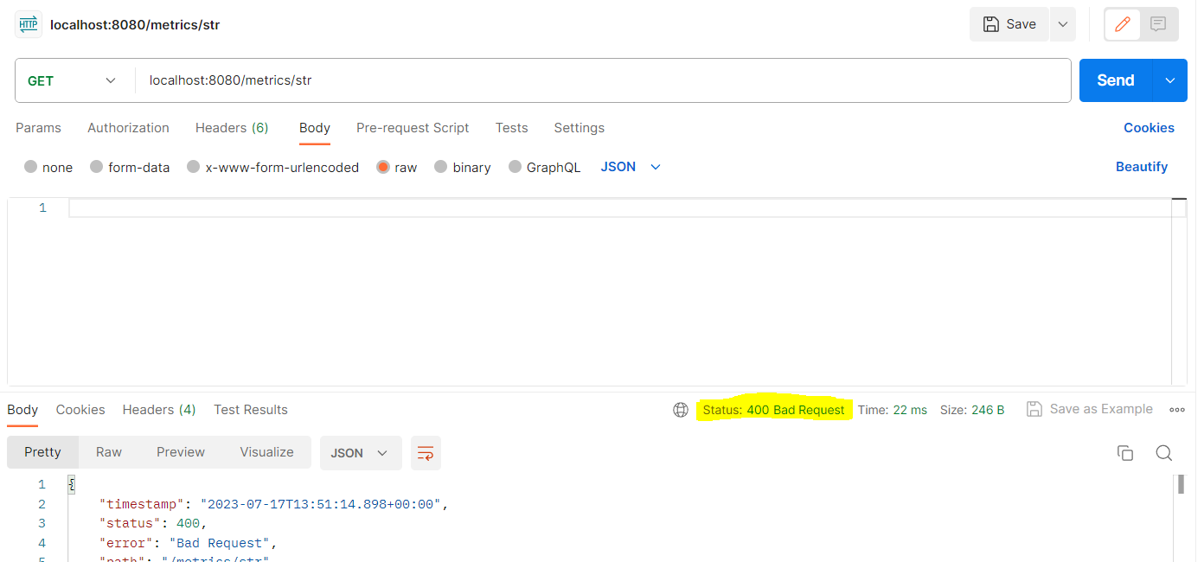

1. POST/metrics

{

        "system": "System1",

        "name": "Metric1"

}

{

        "system": "System2",

        "name": "Metric2",

        "fromDate": "19/07/2023 01:44:20"

}

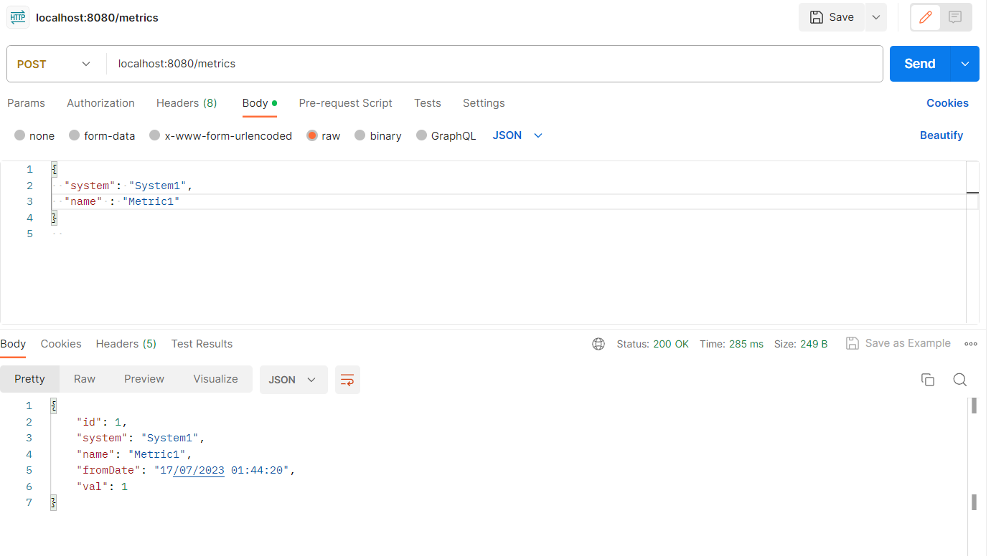

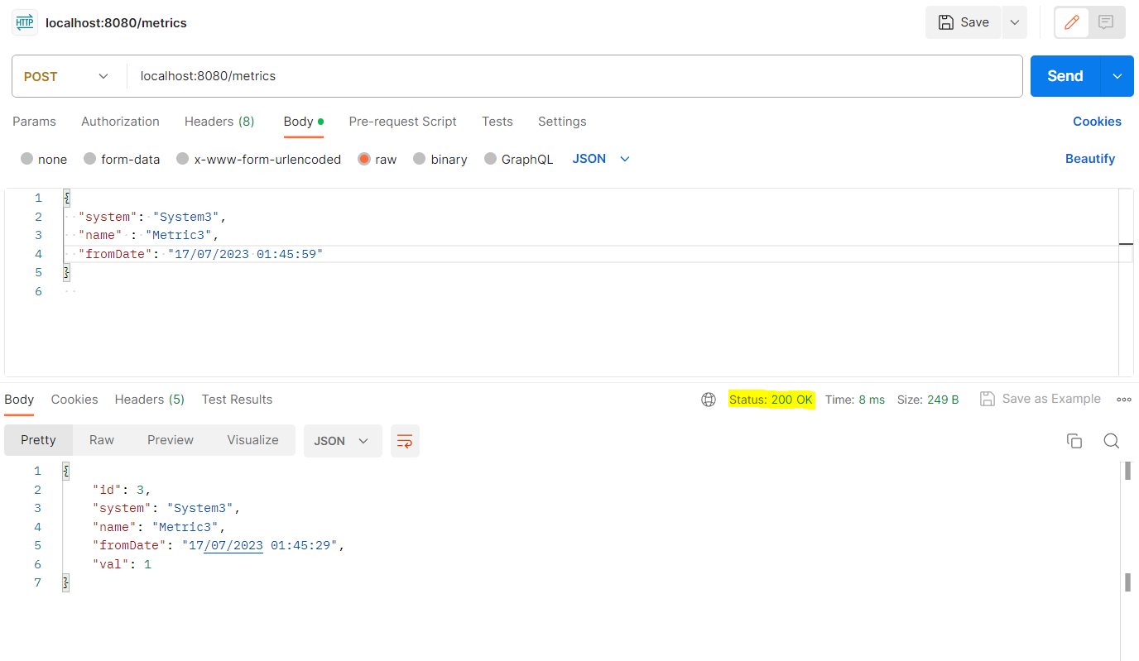

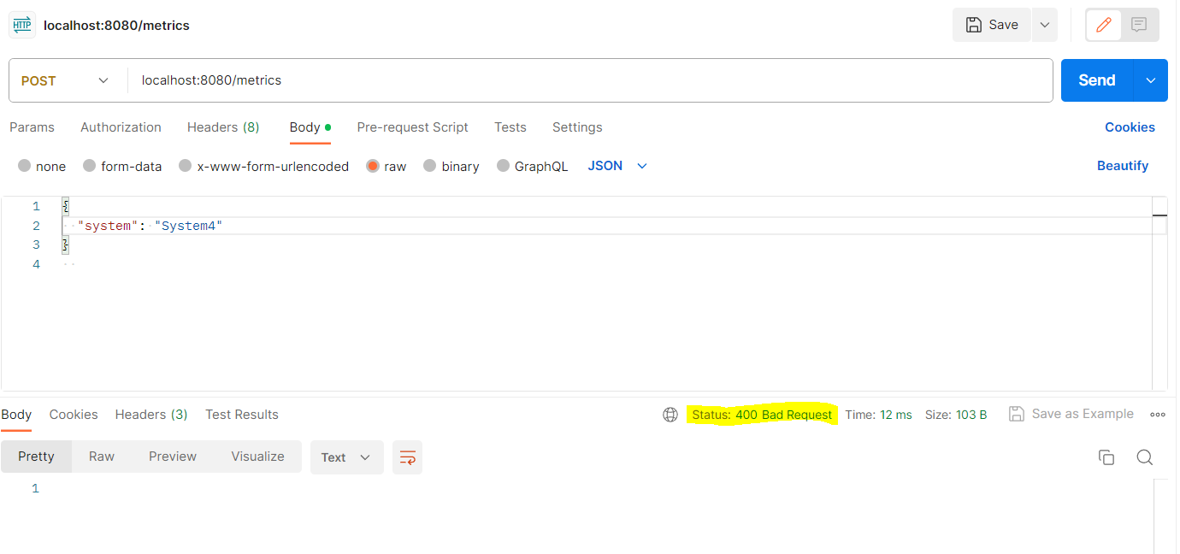

1. PUT/metric{id}

{

  "system": "System34",

  "name" : "metricNameChange",

  "fromDate" : "19/07/2023 01:44:20"

}

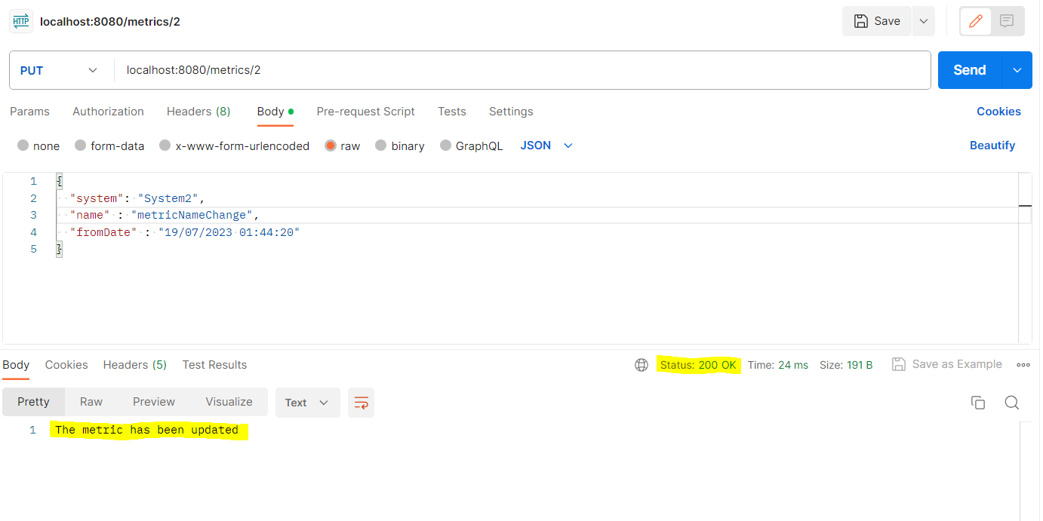

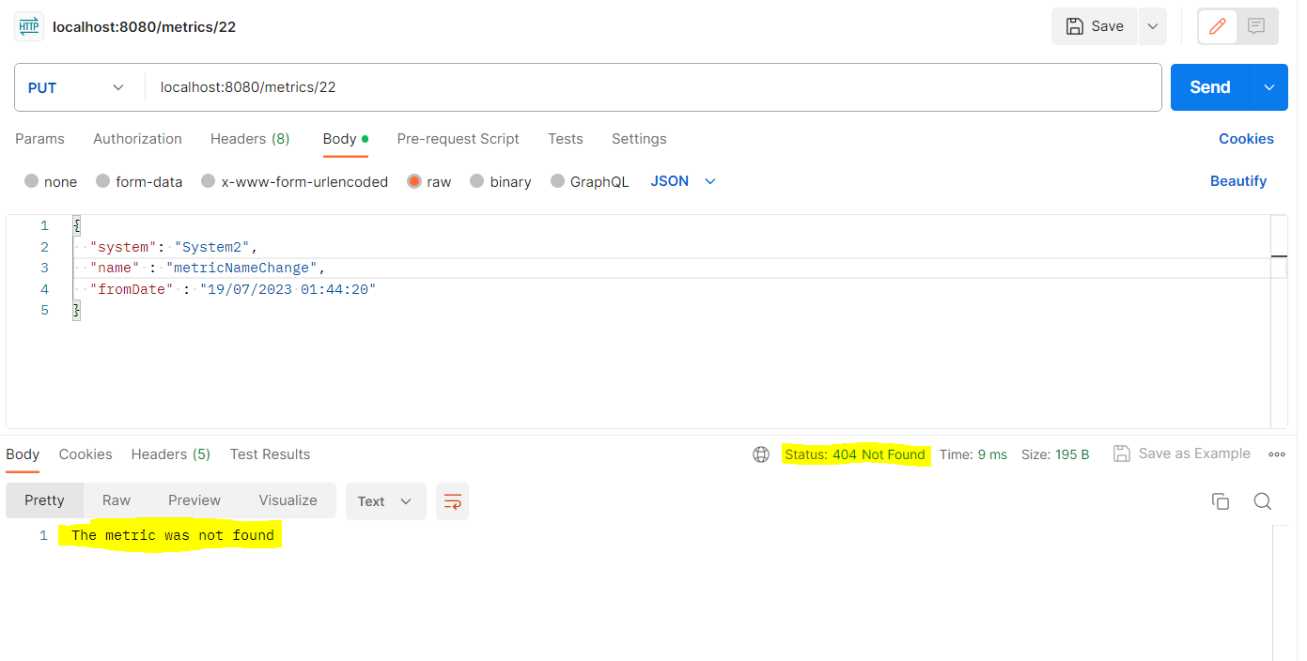

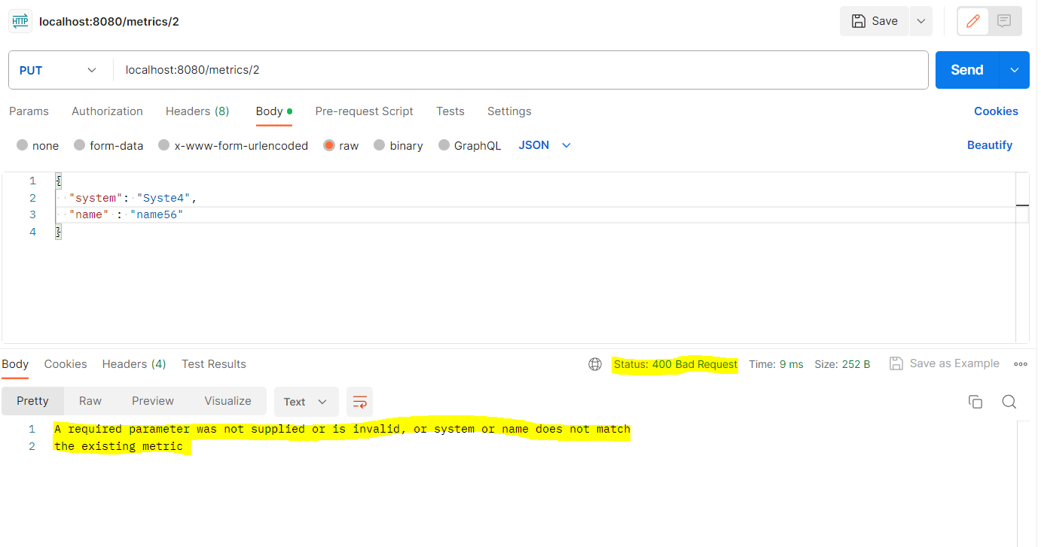

1. DELETE/metric/{id}

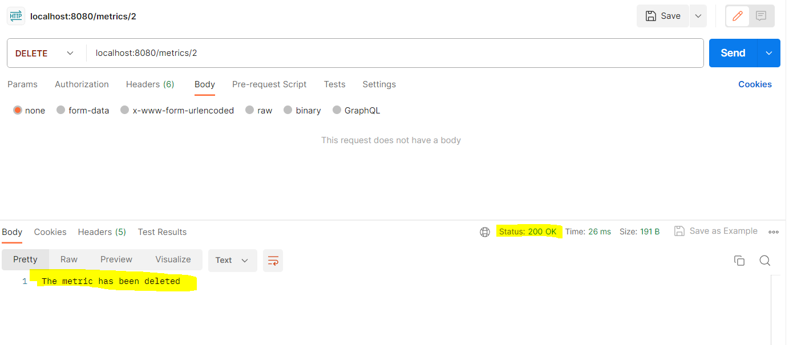

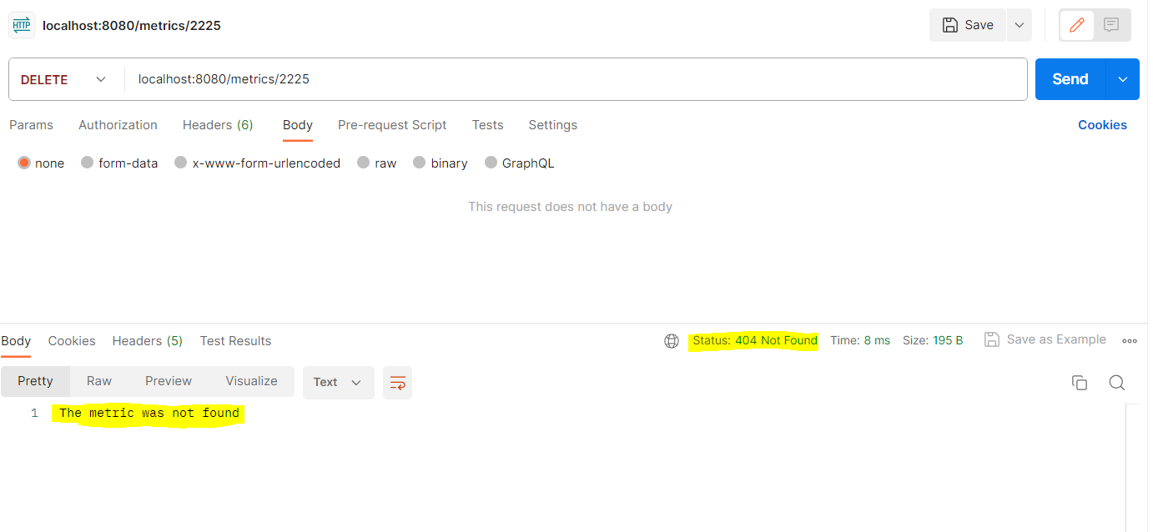

1. GET/metricsSummary

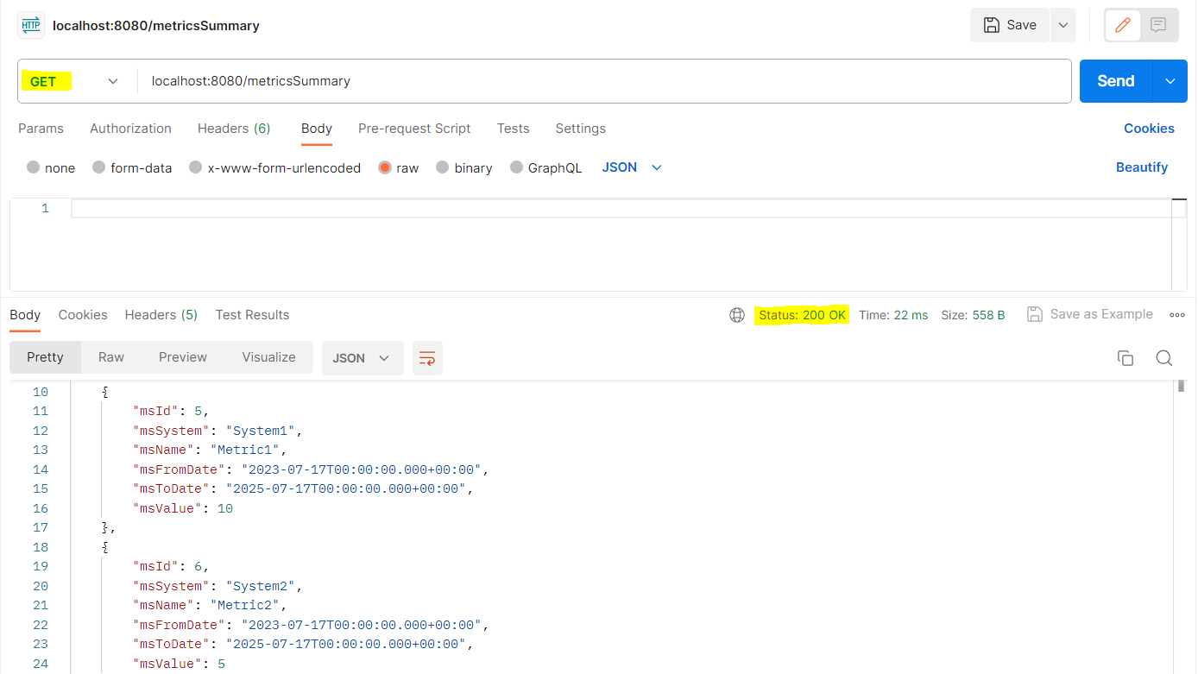

1. POST/metricsSummary

{

        "msSystem": "System2",

        "msName": "Metric2",

        "msFromDate": "2023-07-17",

        "msToDate": "2025-07-17",

        "msValue": 5

}

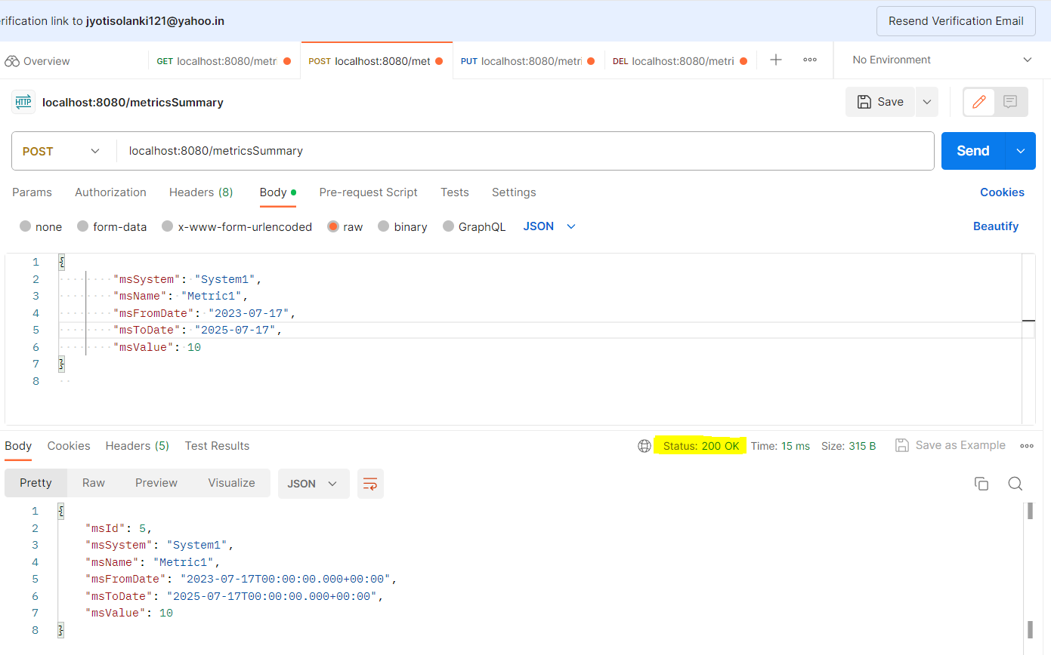

**LOGGING :**

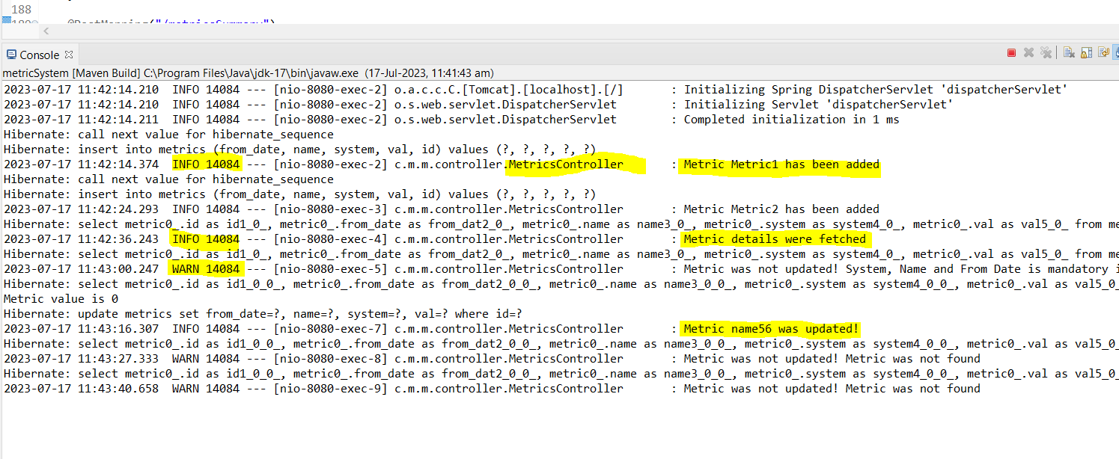

**JUnit Testing:**

